BRING YOUR TICKET!!!!!
BRING YOUR Team TSHIRT!!!!!
Main Leaders Contact
Richard Ng : 214 893 8981 Stephanie Ng : : 214 718 8368

US LEADERS
Gim Teoh: 1 (469) 463-3450 Soo Leng TOh: (469) 463-3450 Stephanie Nguyen: (972) 693-3330
SG LEADERS
Jessica Lee : 65 9666 3602 Fiona Tan: 65 9383 9336 Verna Tay : 65 9199 4338:
Andrew Ho : 65 9792 4638 Delphine Ho: 65 9628 5310
MALAYSIA LEADERS:
Kean : +60 17-250 6104 Susan Na: 60 19-280 6845

Venue
Conference Location:
Break out Location & Host Hotel:
Host Hotel: Koury Convention Center
3121 High Point Road, Greensboro, NC 27407
Phone: (336) 292-9161

Greensboro Coliseum
1921 W Gate City Blvd, Greensboro, NC 27403
Phone: (336) 373-7400
Team Get together:
Wednesday : 5pm – 7pm : Leaders Meeting
Announce Daily at conference: Lunch MAM for conference
Saturday :8pm – Team Lunch
MAM Assignement & Seat Monitor
Thursday – US Team
Friday – SG Team
Saturday – MYS Team
T-shirt: Color Assignment
Day 1 - Green
Day 2 - Black
Day 3 – Funtrepuner - Peach
Day 4 – Purple

Gala
Please Note to check in and receive your wristband prior to attending the Gala, and your wristband must be worn at all times. Check-In will be on August 08, 2019 and August 08, 2019 upon entering the Coliseum during Convention.
GOTO Leaders : Fiona Tan, Gim & Soo Leng
Gala Table : !43 & 142
Team Logging
USA TEAM
Comfort Suites Four Seasons
Address: 3308 Isler St, Greensboro, NC 27407
Phone: (336) 235-4002
Room Block Team R&S
Breakfast Included
SINGAPORE/MALAYSIA TEAM
Host Hotel: Koury Convention Center
3121 High Point Road, Greensboro, NC 27407
Phone: (336) 292-9161

Suggested Airport
RDU - Raleigh–Durham International Airport (64 miles from Convention Ctr)
CLT - Charlotte Douglas International Airport (94 miles from Convention Ctr)
GSO - Piedmont Triad International Airport (15 mins from Convention Ctr)
Best airport to come into is RDU
GSO is closes but also the priciest.
Suggestion to Come in on Wednesday and leave Sunday to airport after 2pm
Team Transportation
US TEAM
- Team Team Sharing Transportation
- Please List pickup time for transportation
- Rental/Parking/Gas = $35 - $45 Entire Trip

Singapore Team – SG Leaders Arrangement
Transportation RATES
UBER/Lyft
UBER ESTIMATED RATE:
The minimum fare is $5.85. The base fare for the service is $1.20. The cost per mile is $0.86 and the cost per minute is $0.15.

Lyft
- Initial cost: $1.20
- Service fee: $1.90
- Price per minute: $0.15
- Price per mile: $0.80
- Minimum fare: $4.90
- Maximum fare: $200
- Cancellation fee: $5
fits 4 passengers
FOOD

Lunch on your at convention accept on Dates at combine Team coring or Leaders Meeting.

Communication
Please place your order on whatsapp CHAT! #MAIC2019

INTERNATIONAL TEAM
BRING YOUR TRAVELING DOCUMENTS BEFORE YOU LEAVE !!!!
VISA (IF APPLICABLE) & PASSPORT
- TO DRIVE IN USA YOU WILL NEED INTERNATIONAL DRIVER LICENSE
- Pack Cash: recommended $1000 USD
- Get Router for phone ( workout with the team to share)
- Sim Card for phone
- Passport
- Valid Credit Card ( visa/master)

WIFI Suggestion (Portable Modem)
Getting a portable modem is suggested for international traveler that like to get wifi when they travel.

Here is the website that you can get the router from https://visionglobalwifi.com/usa/
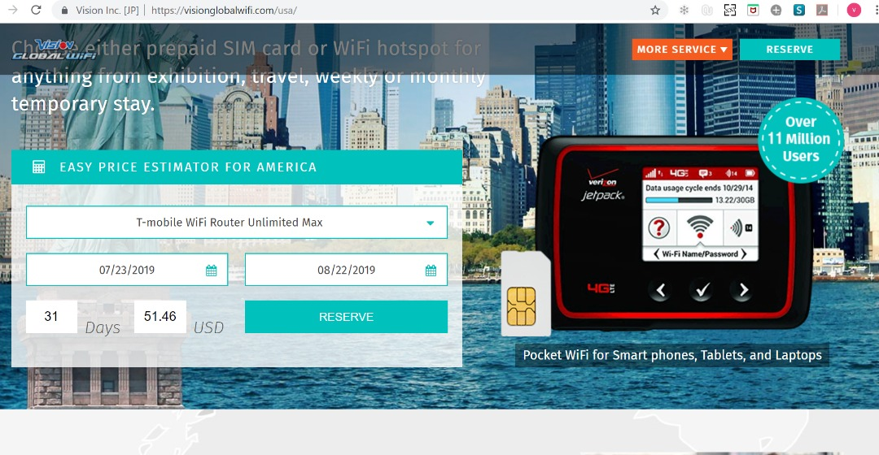

The Modem/Router is usable for one month, after research you pay what most modem charge for 2 weeks. Highly recommended by Vivi due to pricing and it has unlimited data. Device can be delivered to hotel with a fee of $8 dollars. To Return Modem/Router , put it in the envelop given, and drop it off at the any post box

She has found that this is the best option so far.

Other options Includes:
1) Starhub prepaid Happy Roam 150RM for 5GB 30days

2) https://freetoursbyfoot.com/sim-cards-for-the-usa/ Options from 120RM for 2GB

Easiest way to purchase is at Times Square.

THINGS to CONSIDER when you going to Conference
Supplement suggestions
- For energy: Turnup/Bs/Mochatonix/Awake/Thermochrome
- For stress: ACTS/Bliss/Turn Down
- For headaches: Oxygen Extreme, Magnesium
- Bowel movement: TLS shakes/Fiber powder
- Snacks: TLS bars/Shakes
- Indigestions/Diarrhea Preventions: Digestive Enzymes
- To survive the week: OPCs & Daily essential packets
- Inflammation of the join: Omega/OPC/Joint/Curcumin
- Focus Vitamind/Mochatonix.
- Breakdown Fat/prevent Fat Storage: CORE/CLA/Enzymes
- Want extra Burn: CG/Thermochrome

Personal Care
1) Recommended Travel Size for skincare and Royal spa if you have, Or Room sharing
2) IF you have New People Make it a shopping annuity Trip for new folks
3) Make up, simple suggestion for non Divas, A simple pallet with foundation and sunscreen will be ideal.
4) For DIVAs you bring what you need. Just be aware to Check in the make up and not hand carry it. Be aware It will also put additional weight on your bags
5) Hair products – recommend Room sharing. Unless the Room group do not bring

Washing
- Dry Cleaning Option
- Laundry option available as well

What to expect at conference?
- EVERYONE MUST BE AT SEAT BY 8:30am No later. Adjustment will be made, via Seat monitor suggestion once we have been seated on the first day.
- Please note CANNOT bring food into convention center
- GMTSS & trainers please goto Table pick up tags
- Know who your GROUP LEADERS ARE
- Be sure you have leaders contact
- USA/SG team contact your person In charge(PIC)
- Please DO NOT Walk around during conference, especially during JR and business building segment. Be in your seat during recognition. If you have to leave do it in the morning. You can walk during product segment other than nutrition/beauty/TLS.
- Put something in your seat when you get up and leave the seat
- IMPORTANT: Stay in your seat when we get in until all team are seat and Usher ok us to move!!!
- Battery pack to charge phone
- Phone have enough space to take pictures and video
- Just in case: Umbrella & rain coat
- Jacket at the conference will be cold
- Walking shoe will need to walk
- Note book
- A touch light to write in the dark at conference
- Bring enough Cash.
- Your convention Tickets
- Team Tshirt
- Extra folded bags just in case you need extra bag
- Plan your breakouts and which breakout your like to take on. Please with team so you can all get what you need for your organization

Tickets
- Prep $$ for next event tickets
- Prep You Team
Leaders
- This is a time to do planning and meet with all your team members
- Plan for time to go over 6 months of team goal and direction.
- Set time with R&S to go over team direction if needed

US Team Expense Breakdown
TEAM Vehicle Rental & Parking: $35 to $50
Lunch EST in your control: $15 to $30
Rooms : $119.95 single/double

Flight
USA Flight Pricing$250 to $550

Tickets
Cost of tickets $200
Keep 3 tickets purchases 4 next event $600

Team Dinner : $10 to $20

